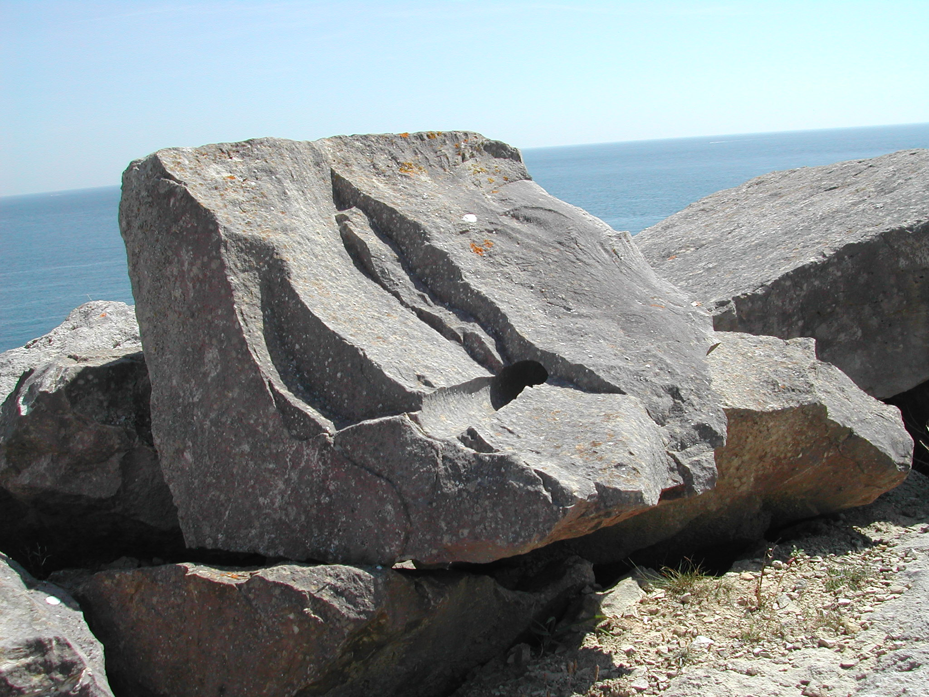

The themes explored in Portland Stone – the ultimate building material, are designed to be used in conjunction with other resources to teach Unit 9G. The lessons provided deal with the chemical breakdown of rock, both in the landscape and when used for construction of buildings. Students will also carry out a range of experiments in class, which will require them to make predictions, plan, record results in an appropriate manner and use the information gained from the experiments to complete further tasks.

