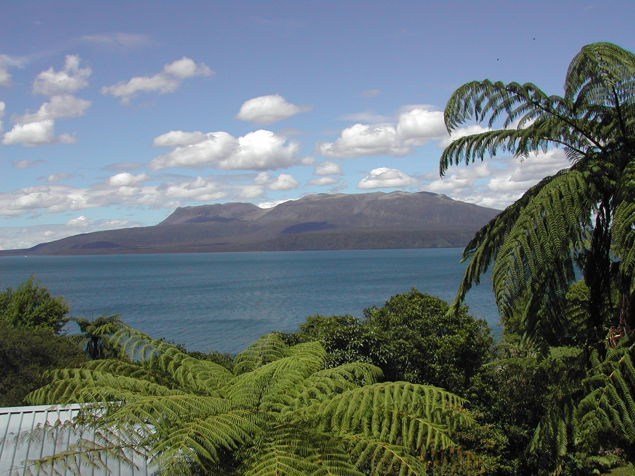

The Unit will encourage pupils to:
- Develop their skills of scientific enquiry
- Investigate the relationship between crystal size and method of emplacement for igneous rocks
- Relate particle size to method of transport for clastic sedimentary rocks
- Appreciate that not all carbonate rocks contain fossils
- Use modern examples to aid understanding of processes that have taken place throughout geological time

