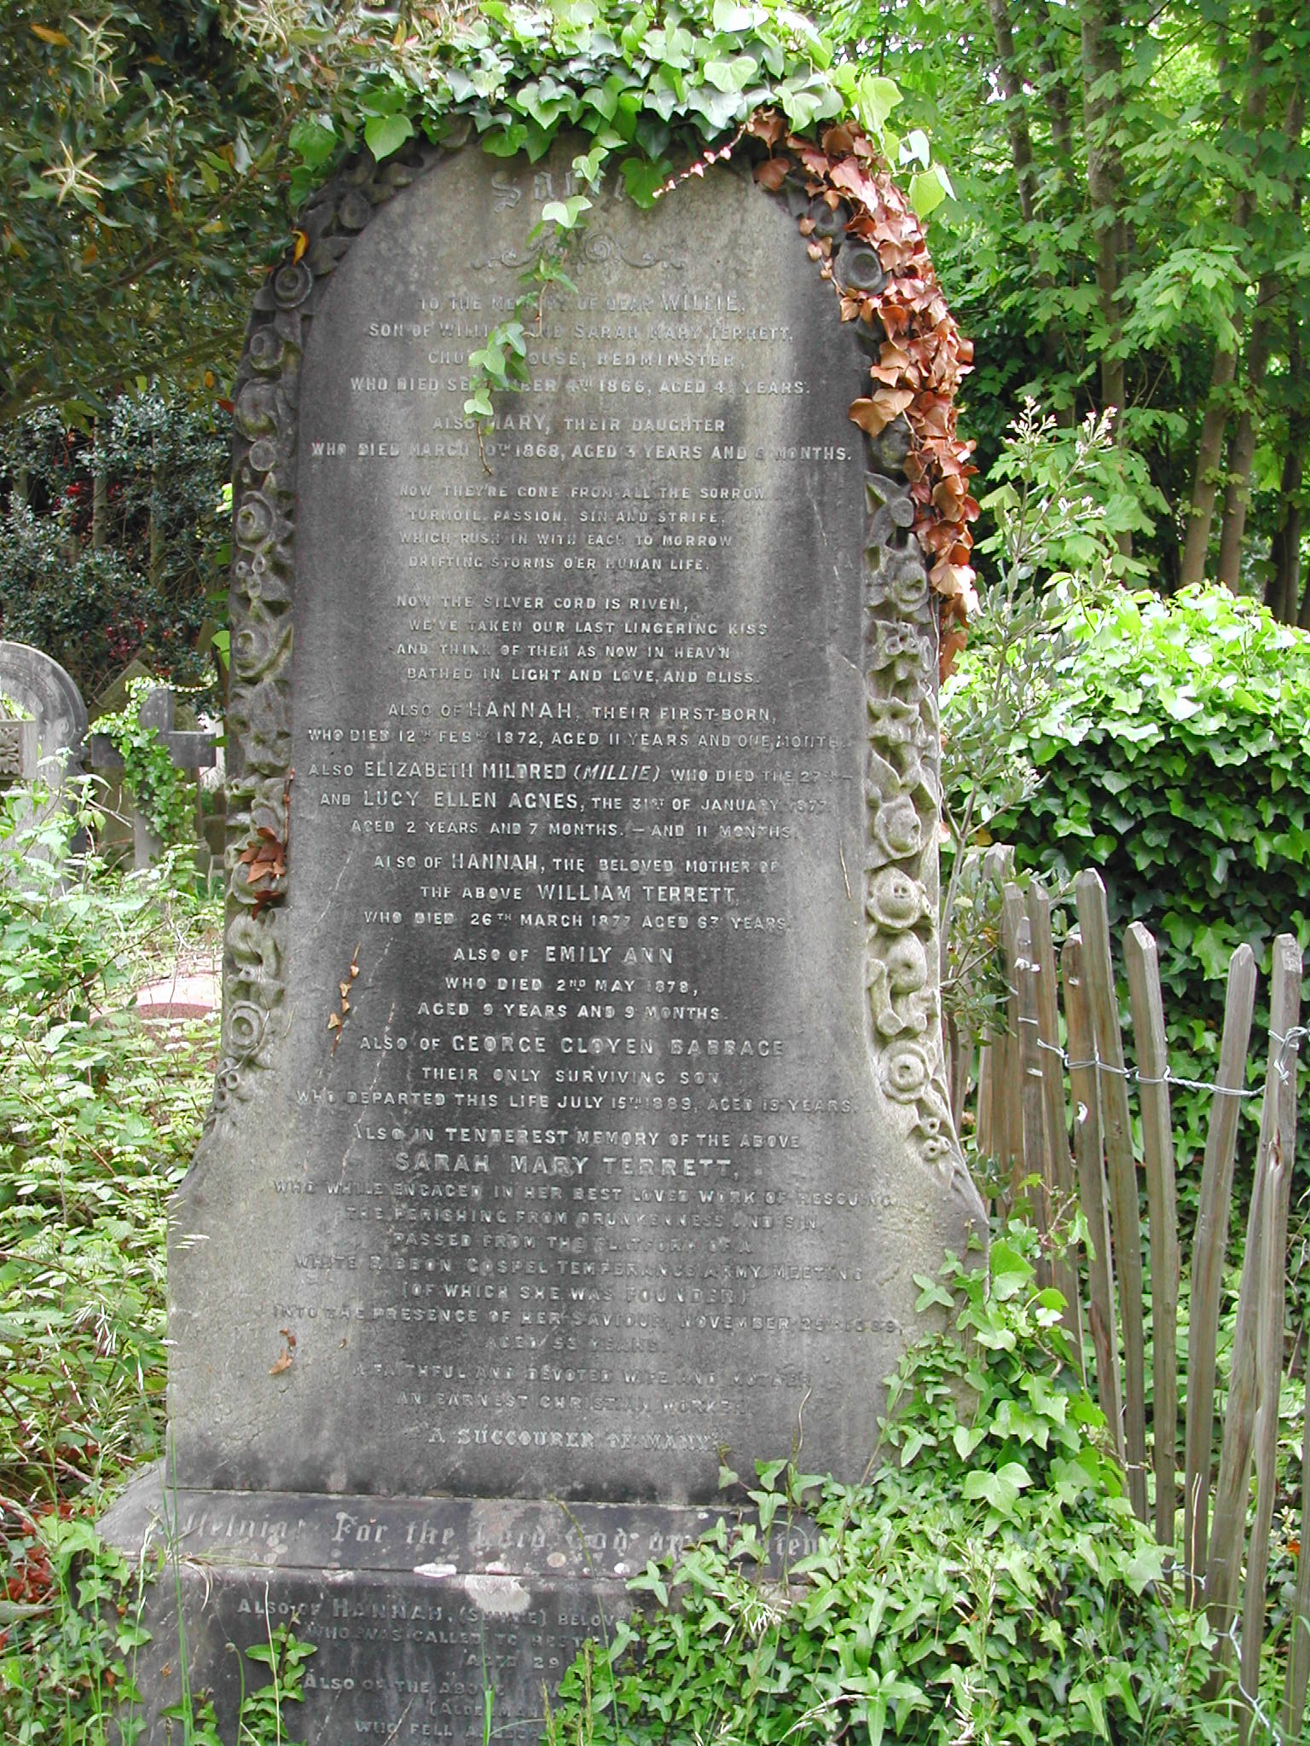


To explore the role played by water in the breakdown, transportation and eventual deposition of sediments.

The range of weathering processes that can attack rocks will be explored by focusing on the way in which the dominance of either chemical or physical weathering is determined not only by the availability of water but also by temperature fluctuations.

