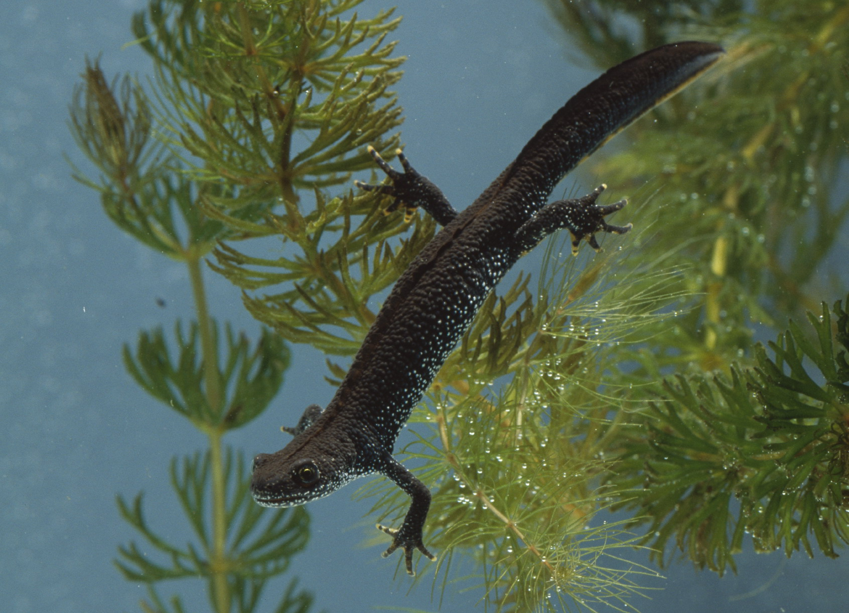

‘It’s the Pits’ – life in a restored gravel pit
‘It’s the pits’ provides a stimulating way to fulfil the requirements of Unit 7c in a combination of four lessons (approx. 50 minutes per lesson), one four-hour practical fieldwork session and one practical session in the lab. Using their own data from fieldwork brings ownership and engagement to the work.

Pupils can learn about a working gravel extraction pit using the ‘Virtual Quarry’ resource and how this could be restored when the extraction is completed. By using secondary resources the pupils can learn about life in a still freshwater habitat and consider how habitats vary within a gravel pit, adaptations to living in different habitats, interactions between plants, animals and environment and feeding adaptations.

They can also design and carry out a fieldwork investigation in a local disused gravel pit, lake or pond and follow this up with the design and execution of individual experiments.

