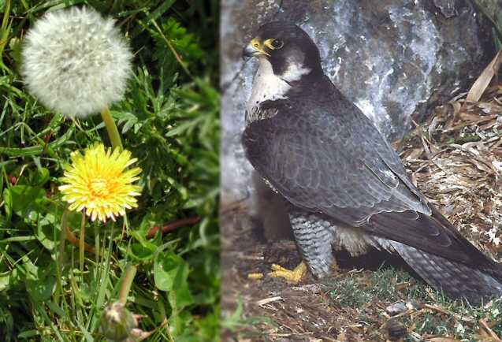
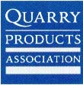

Undertaking this unit, the children look at the life cycles of a plant and a bird that are both found in a working quarry. They investigate how plants manage to grow in working quarries and create a first-person diary account, imagining they are a dandelion! They also look at the increasing incidences of peregrine falcons nesting in working quarries and find out about these exciting birds and their life cycles.

