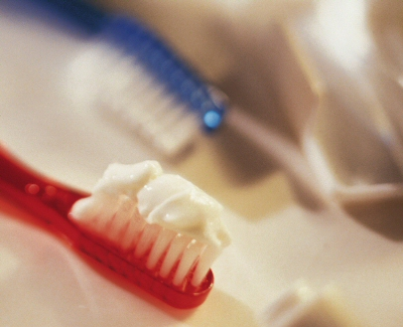
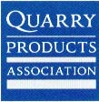
Toothpaste Technology
Undertaking this unit of work, learn about the many objects and items in our everyday lives that come from quarried products. Since toothpaste contains quarried limestone, this forms the basis of this unit. Children experiment in making their own toothpaste, investigate commercially produced toothpastes and then devise an investigation to test their own toothpaste against the common shop-bought brands. Combined with this unit are strong literacy links, as children create instructional texts and adverts to promote their new brand of toothpaste.

