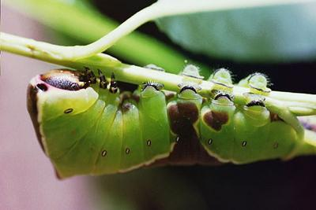

The ‘Herbivore Heaven’ café is under new management!
Undertaking this unit of work, children imagine that they are the new owners of the ‘Herbivore Heaven’ café now set up in a restored quarry where wildlife is returning. Through developing menus and looking at the animals that may visit their café, children learn about food chains in a fun way. With excellent opportunities for Literacy in the development of menu cards and Science investigations, when finding out which leaves snails prefer to eat, this adapted unit gives a new slant to the Science 4b unit on habitats.

