Worksheet 5 “The strongest sand or soil castle”

Notes for teachers
- Select View – Reading Layout;
- On the toolbar select ‘actual page’ and the ‘multiple page’ option.
Please delete this text box prior to use.

Destroyed | Very damaged | Some damage | Intact
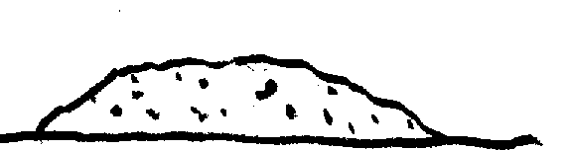 | 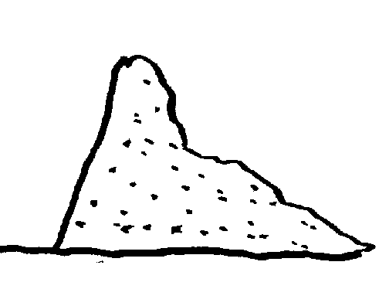 | 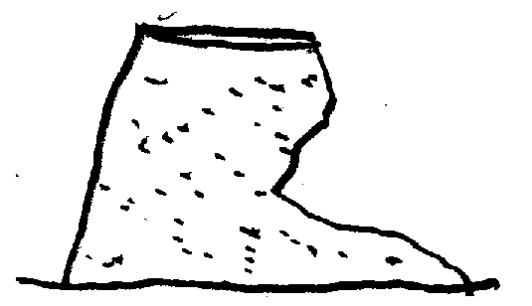 | 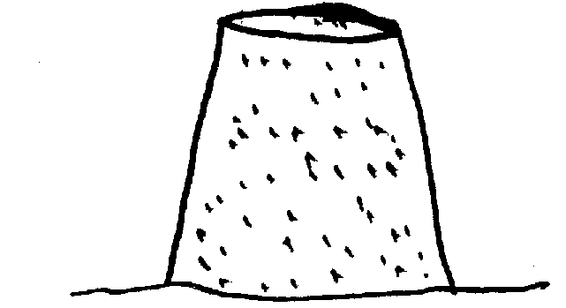

This key shows how much damage is done to the castle in the test.

1. What happened to each castle?
The material that was used to make the castle | What happened?
Sand
Soil
Sand and gravel
Wet sand
Wet soil
Wet sand and gravel

Symbol bank Drag and drop pictures

2. Which of the castles that we tested was the strongest?


3. Why do you think this castle was strong?


4. Which parts of the test were not fair?


