Notes for teachers
To use this worksheet on an interactive white board select:
- View – Reading Layout;
- On the toolbar select ‘actual page’ and the ‘multiple page’ option.
Please delete this text box prior to use.

Worksheet 4 “Which is my favourite soil?”
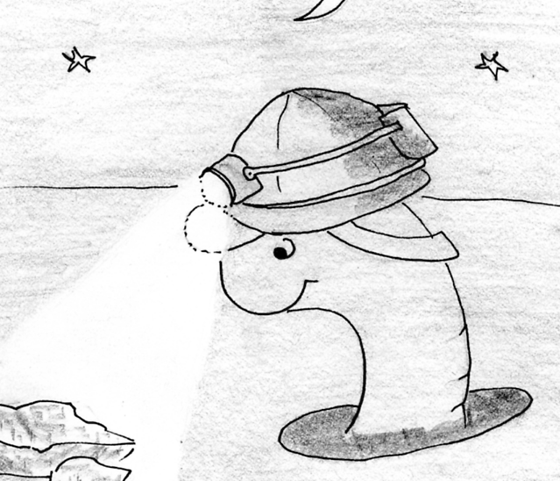
“Worms like me are very interested in soils!
We tunnel in the soil. We gobble up all the tiny pieces that are in our way. We use the tiny bits of rock to help us munch up bits of dead plants and animals.
Dead plants and animals are our food!”

1. “Look closely at these three kinds of soils.
List down all the different things you can see in each soil.”
1. First sample | 2. Second sample | 3. Third sample
I like

2. “Which of these soils would I like to live in?”

3. “Why do you think I would like to live in it?”
It is best because

