Worksheet 3
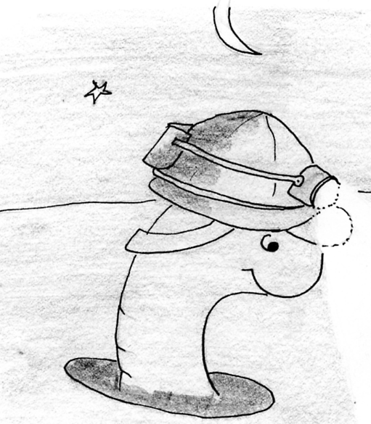
Notes for teachers
To use this worksheet on an interactive white board select:
- View – Reading Layout
- On the toolbar select ‘actual page’ and the ‘multiple page’ option.
Please delete this text box prior to use.

Search with the rock and soil expert.
s | a | n | d | a | b | o | n | e | s | d
o | c | l | a | y | o | r | o | o | t | s
m | u | d | v | p | e | b | b | l | e | s
s | l | u | g | a | l | b | o | n | e | s
e | s | t | o | n | e | s | d | u | s | t
m | u | c | k | i | l | e | a | v | e | s
“Can you see me in the diagram below?
Now help me do this word search!”

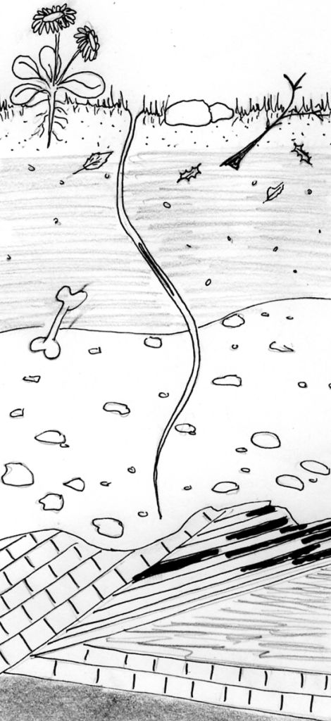

1. “Look in the word search. Can you find some bits of things I gobble up when I burrow in the soil?”

2. “Find some things in the word search that might be too big for me to gobble up?”

3. “There’s another creature in the first word search that shares the soil with me?”

a | s | l | a | t | e | g | a | f | r
c | o | a | l | e | c | h | a | l | k
m | l | i | m | e | s | t | o | n | e
4. Find some rocks down here that are too hard for me to go through?

