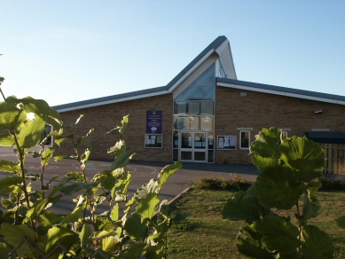
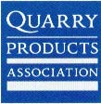

The lessons provided in this unit help teach the QCA Science Unit 3D Rocks and Soils. They will also partially fulfil the objectives of the adapted Year 3 Geography QCA unit “Investigating our local area.”
This is a teacher and child friendly unit. It uses easily accessible resources, often building materials, which have originally been obtained from quarries.

The lessons incorporate a music composition activity, a “rock and soil expert” (the earthworm), plus some “fun” practical science activities which overlap with the curricula for both design and technology and education for sustainable development.

