Notes for teachers

To use this Big Book select:
- View – Reading Layout;
- On the toolbar select the multiple page option..

This Big Book has been designed to be viewed on an interactive white board or large visual display unit.

You may prefer to substitute local photographs to make the book even more relevant to your children.

Please delete this text box prior to use.

The
rock and soil expert!
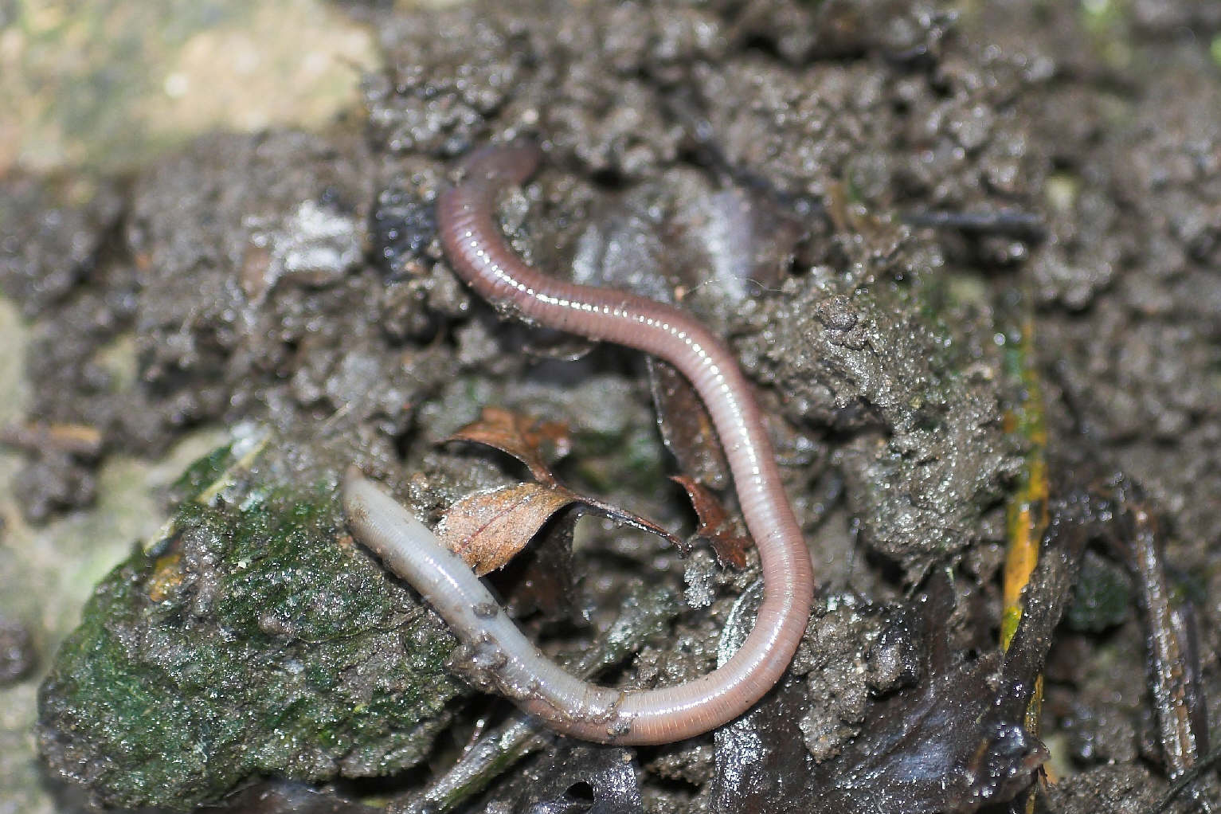
“Do you know why I am an expert on rocks and soil?

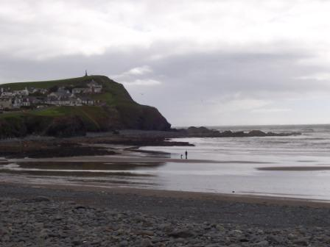

This is a great place to find rocks!

Where can you see rocks in this picture?

I know where there are some rocks
that you can’t see!

Where do you think they are?
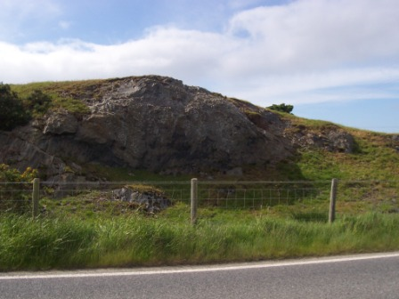

Here are some more rocks by the side of a road.

Think carefully. What else is hidden under the grass?

Here is a clue!
I live in it!

What do you think is
beneath the road?

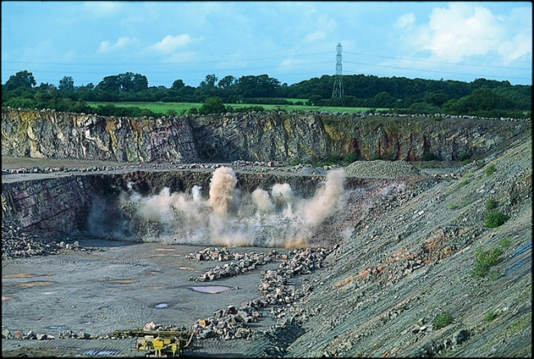

It is easy to see the rocks here.
Why are people digging up the rocks?

Can you see the soil where I live?

What happened to the rest of the soil before the quarry was dug?

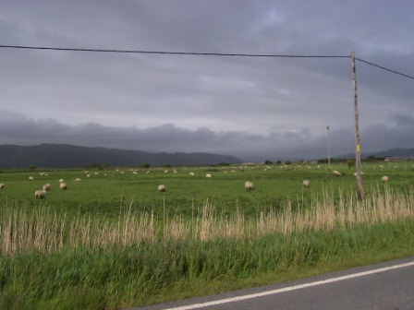

Look at the field in this picture.
I hope you’re becoming experts too!

What two things are under the grass?

What about other parts of the picture?

What’s beneath the hills?

Finally look at this picture.

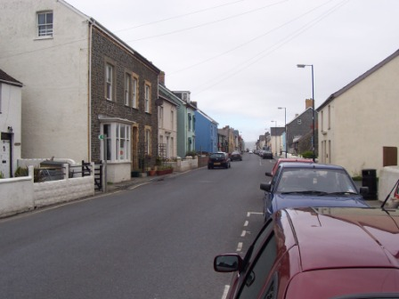
Do you know where rocks are hidden here?

Do you know where there might be some soil hidden as well?

Now, you
are rock and soil experts
too!”

