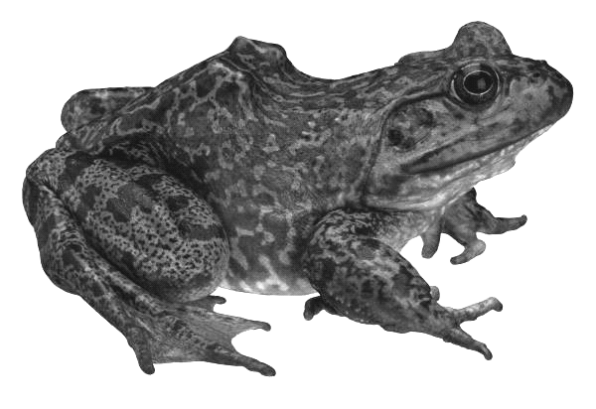
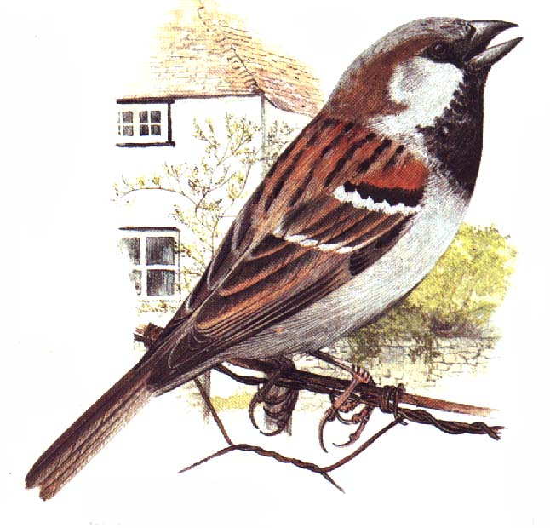
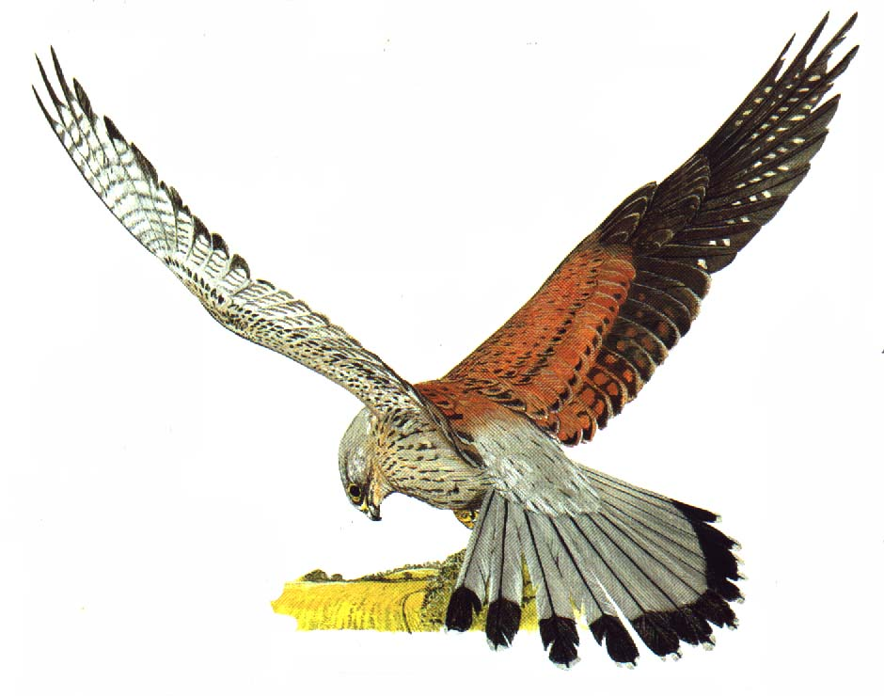
Mouse
Frog
Fox
Dragonfly
Sparrow
Kestrel
Dandelion
Worksheet 1

