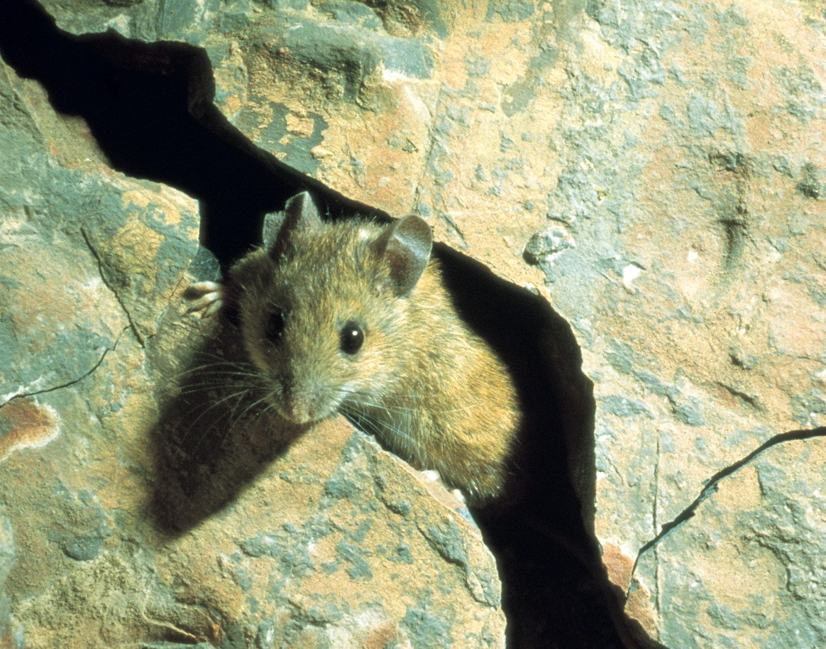


The Quarry Mouse and the Woodland Mouse
Based on the story ‘Town Mouse and Country Mouse’, this unit revolves around the story of two mice, who are cousins. One lives in the working quarry and the other lives in a local woodland. They visit each other’s homes and learn about what it is like to live there. Through working within this unit, children are encouraged to think about different habitats, including that of a working quarry, and what they provide for the plants and animals that live there. They also write postcards and illustrate a book of the story.

