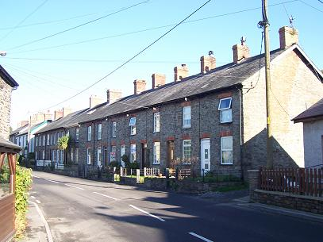
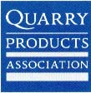
Does that really come from a quarry?
This unit encourages children to think about what is beneath their feet, exploring the fact that most of planet Earth is made up of rock. This unit then encourages children to explore the world of quarries and how this rock is removed from the ground and used to make everyday goods.
Using a feely bag, they explore a range of items made from quarried materials, encouraging an appreciation of the vast number of goods we use in our everyday lives that have been made from materials that have been quarried.

