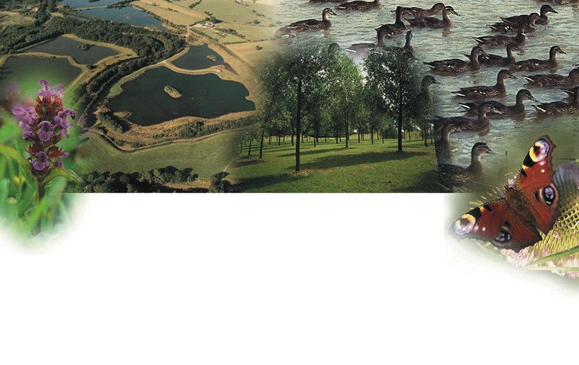

‘Improving the Environment;
a Haven for People, a Haven for Wildlife - or for both?’

In this unit, pupils explore options for the restoration of a sand or gravel pit in the local area. Should it become a water leisure centre, a local park or a nature reserve; or should it just be left as it is? Can any of these uses be combined?

The unit offers opportunities for first-hand research (site visit and questionnaire), the use of secondary sources (local press, radio and TV reports, internet) and the production of a report which can be submitted to the local council.

