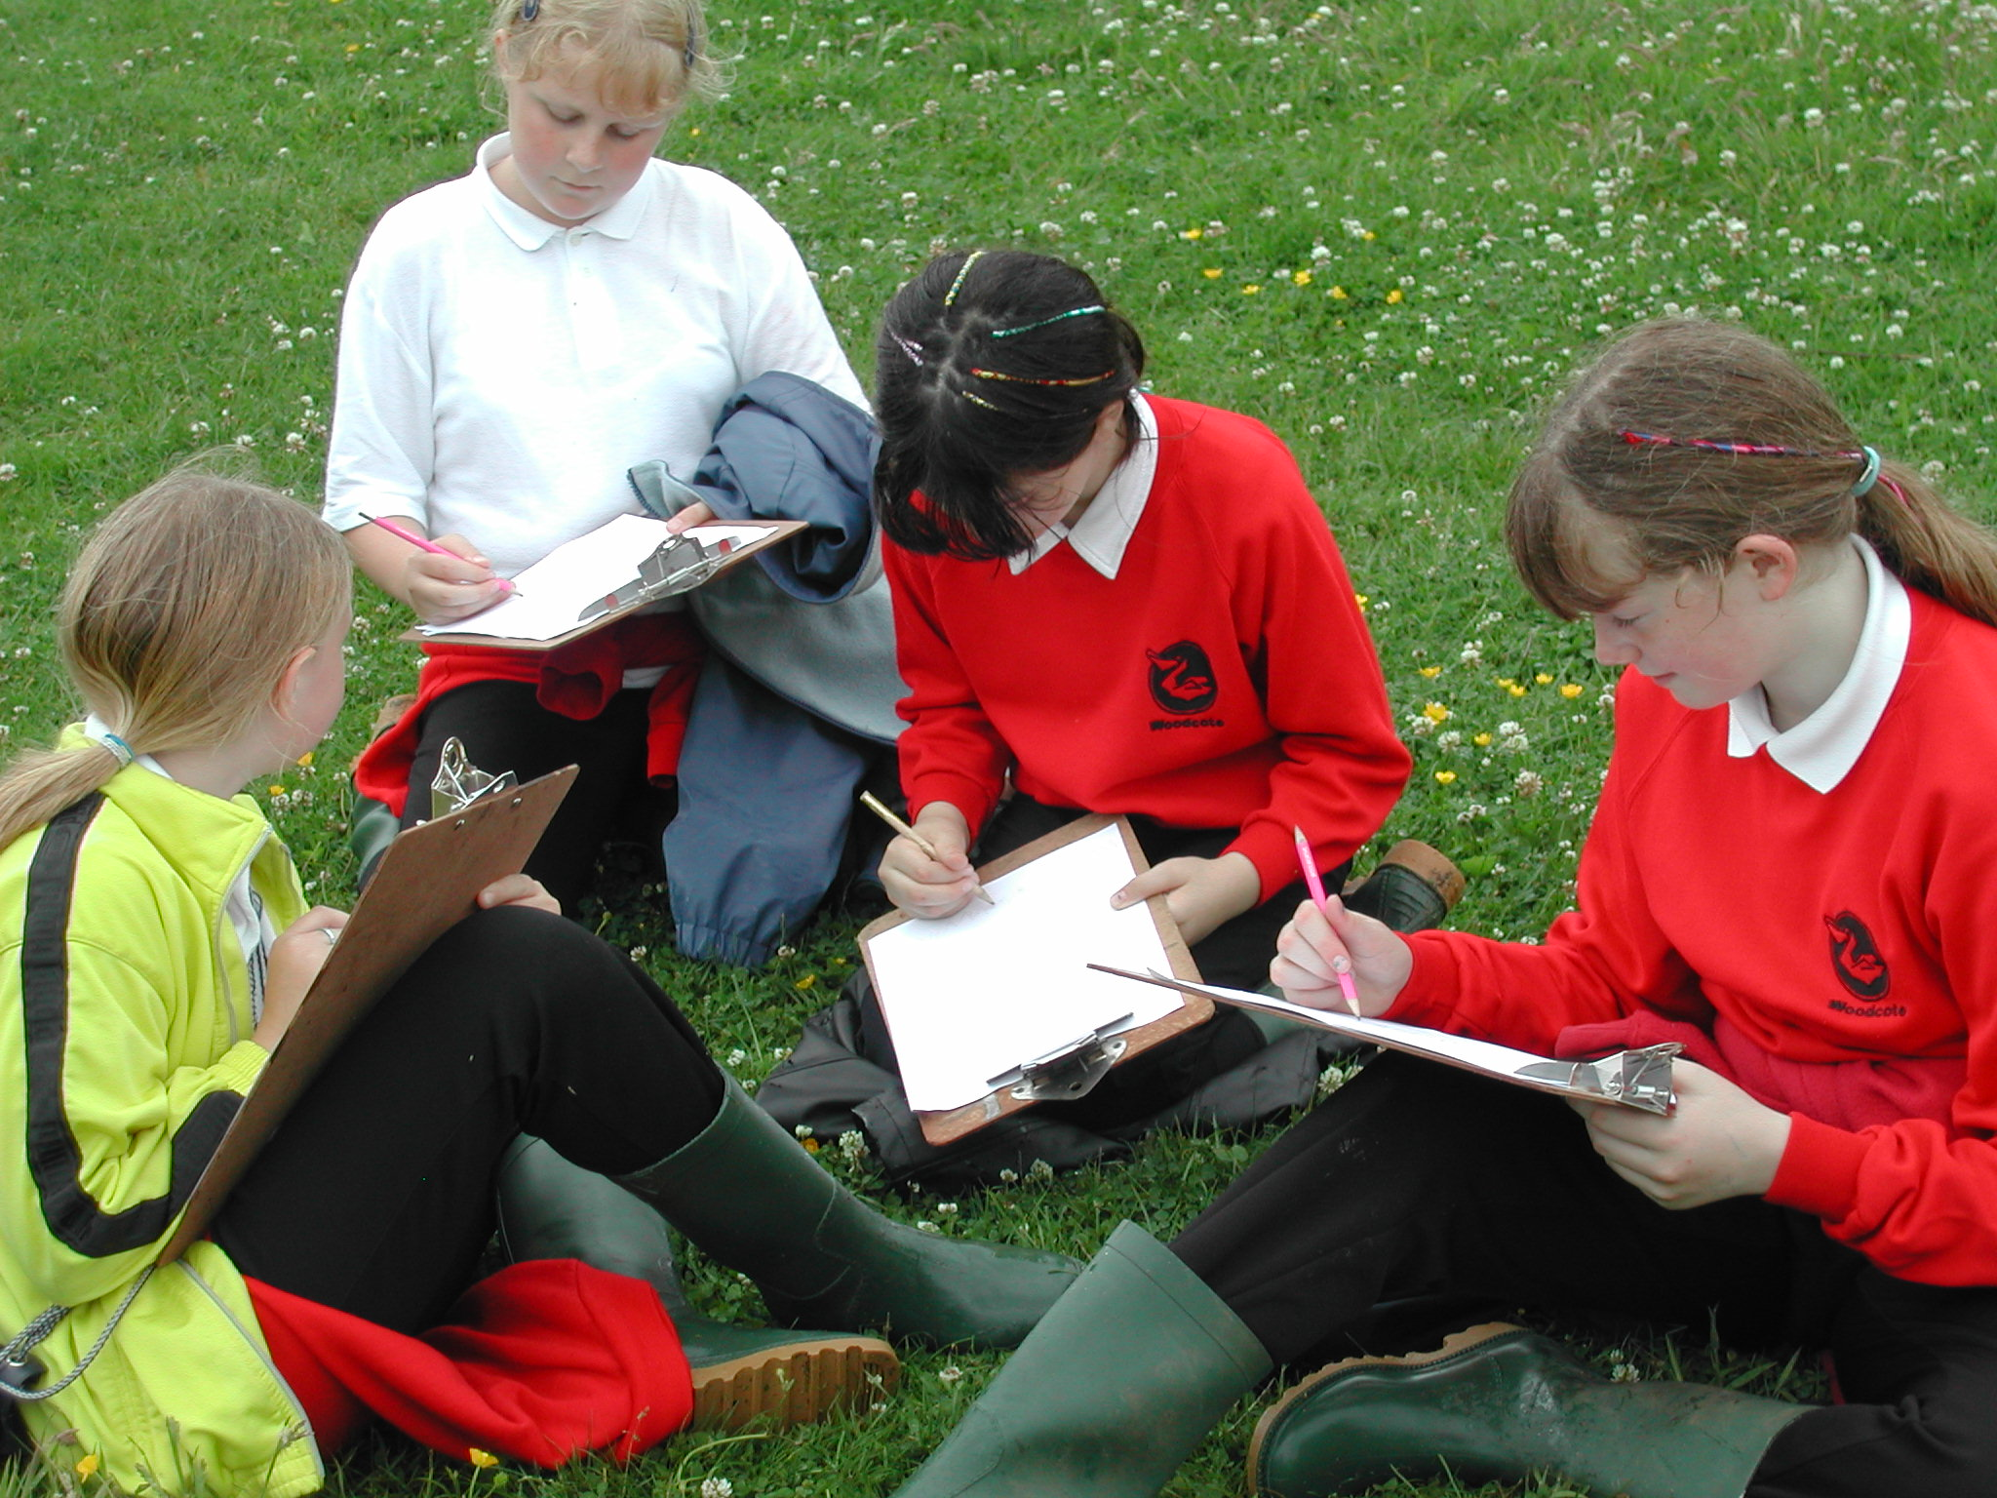

Through this module pupils will be encouraged to:
- Use existing scientific and geographical knowledge
- Use secondary sources
- Develop their observational skills
- Share information in order to answer questions
- Work together to bring skills learnt in the classroom to bear on new problems
- Work safely in the field
- Present the results of a field investigation in a different format

