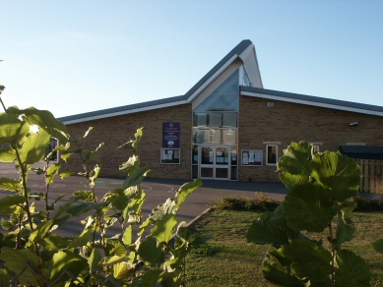

When, as part of their science curriculum, children learn about rocks and soils, they may well ask “What rock is beneath our feet?” This unit encourages children to look for clues to answer this question by looking at the quarried materials used in structures built in their local area.

This unit also uses some of the “fun” activities provided in the Science unit “We’re living in rocks and SOIL!” Teaching both units simultaneously will make efficient use of teaching time and help children acquire a more holistic understanding of the importance of local geology in both shaping their lives and landscape.

In addition, this unit provides motivating opportunities for children to develop skills and knowledge in literacy, PSHE, history and science. Most of the classroom based activities make use of the opportunities provided by ICT and an interactive whiteboard.

