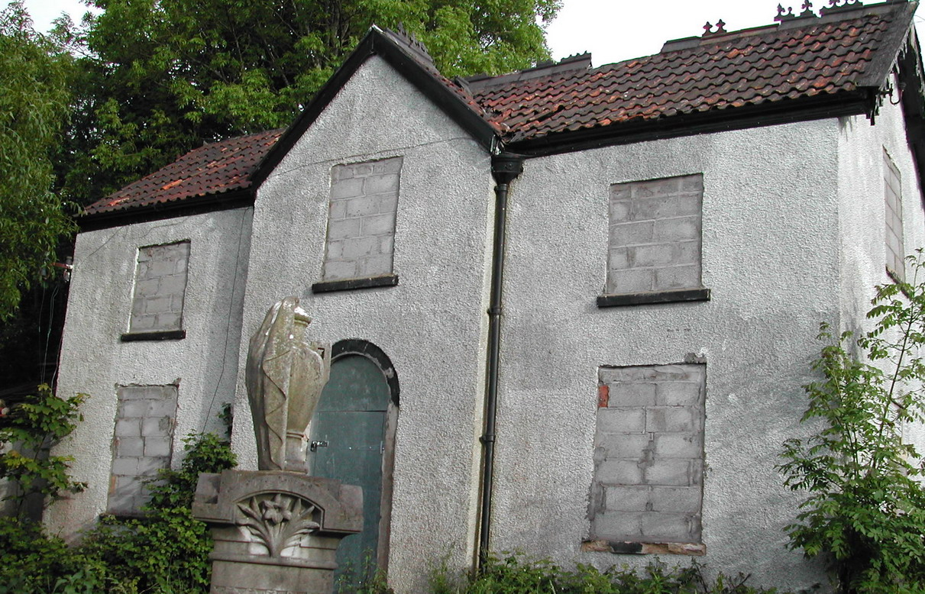

This is a focused local investigation to identify and predict what might happen to a redundant structure. This unit closely follows and meets all the objectives of the QCA Geography unit 20 Local Traffic – an environmental issue.
In this adapted unit children identify both the location of the redundant structure and who will be affected by the change in land use caused by redevelopment.
They look at a range of potential land uses and take part in
a decision making process to decide the most appropriate future use.
By considering the implications of demolishing the structure, this unit teaches children the important environmental issue about why we should reduce the amount of waste going into landfill sites. They learn some of the impacts of committing waste materials to landfill and ways it is possible to reuse and recycle valuable redundant resources.

