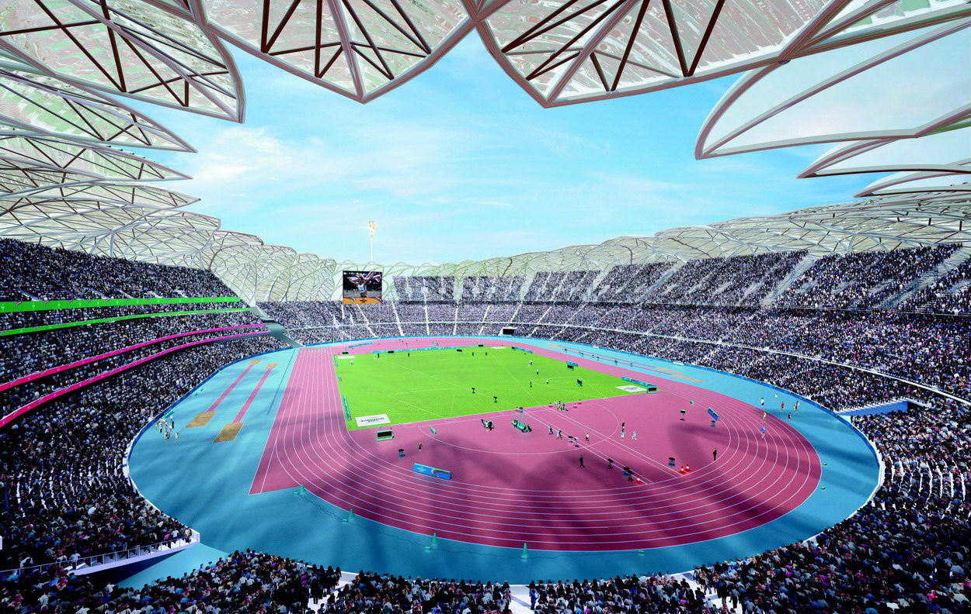

This unit is based upon the QCA Geography continuous unit 16 (What’s in the news?) and is designed to be used throughout Key Stage 2.
It uses news of the design and construction of the venues for the 2012 London Olympic Games, “the most sustainable games ever,” to promote:
- Geographical learning at a widening range of scales;
- Education for sustainable development.

The unit can be used flexibly:
- When relevant developments occur.
- Within and outside designated geography curriculum time.
This unit consists of sets of activities clustered around three general themes.
  - Local and UK Theme: Where will the London 2012 Olympic Games take place?
  - Sustainability: How will the design, construction and use of the games venues help and conserve the environment?
  - The International Connection. How will competitors and spectators travel to the games in an environmentally friendly manner?

