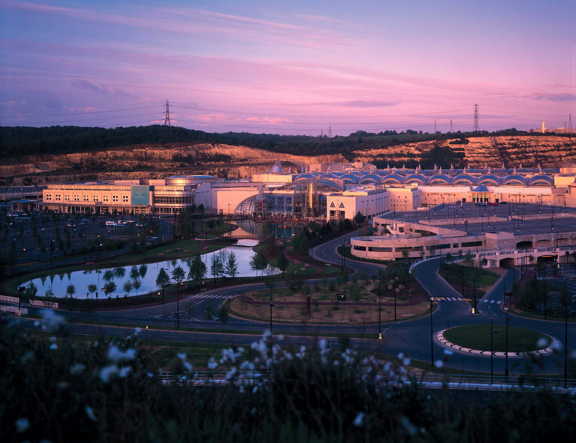

‘Between a Rock and a hard Place’
In this unit, pupils explore options for the restoration of a hard rock quarry in the local area. Should it be used for landfill, a recycling plant, an industrial estate, a retail park, a leisure centre or turned over to nature? Can any of these uses be combined?

The unit offers opportunities for first-hand (questionnaire) research and the use of secondary sources (local press, radio and TV reports, internet); differentiation of ‘facts’ and ‘opinion’; decision-making by groups of pupils and the production of a report which can be submitted to relevant local organisations.

Finally the unit highlights the relevance of studying resource issues in a local context.

