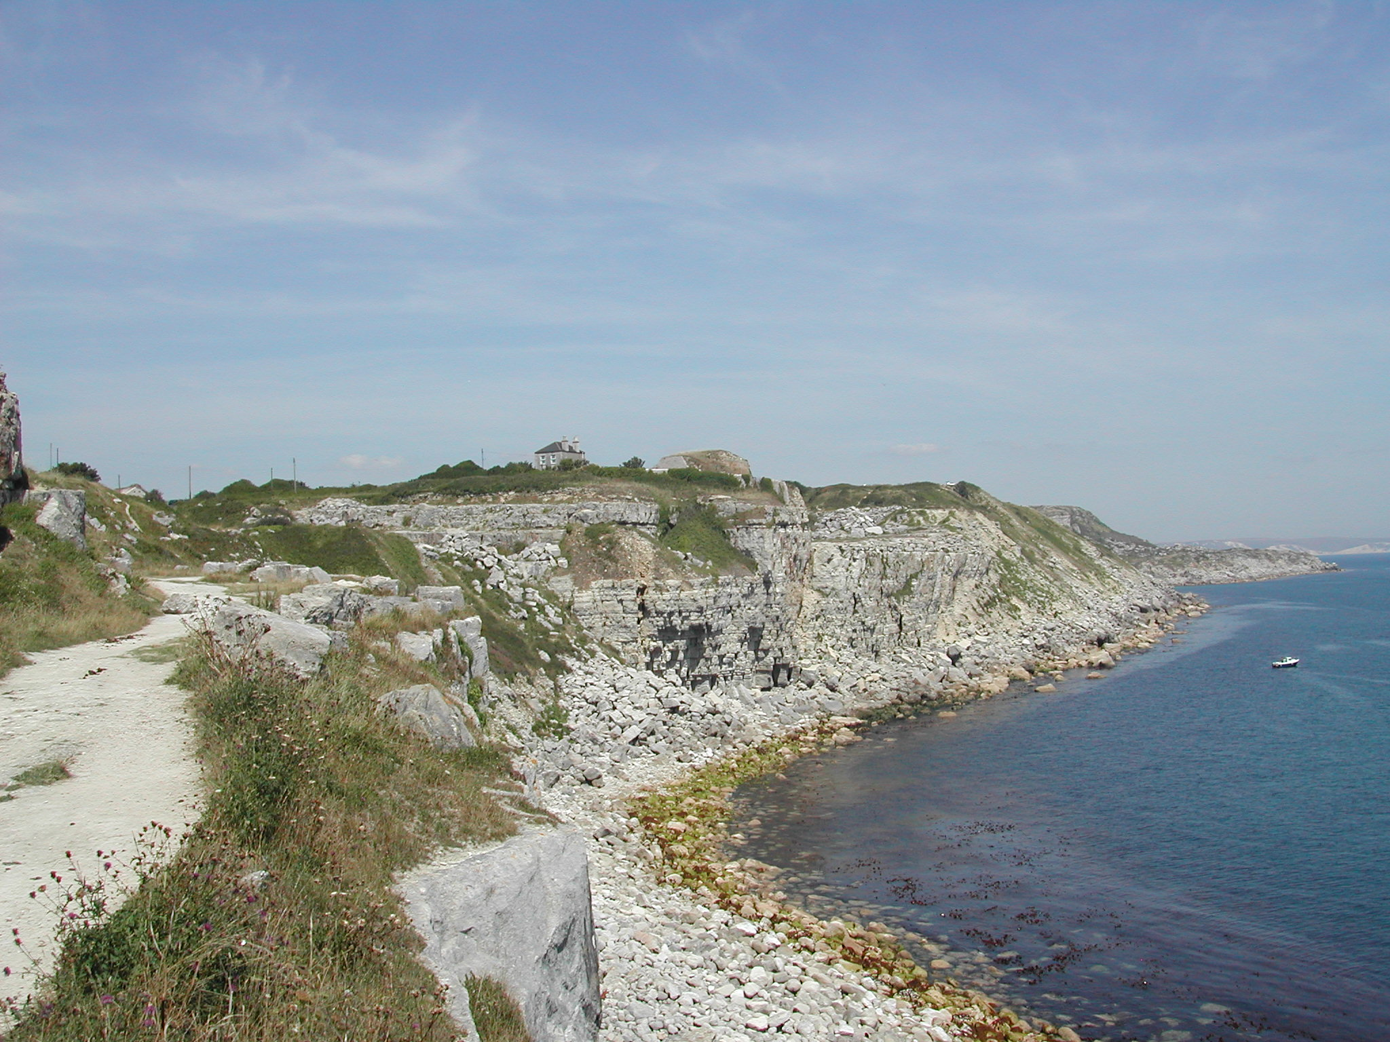

This unit concentrates on the massive limestone deposits of the Midlands and Northern England. Students will be introduced to:
- The geomorphological features found in limestone deposits in the Midlands and the North of England.
- The need to appreciate the fragile nature of certain geological features
- The debates surrounding quarrying in National Parks and Areas of Outstanding Natural Beauty

