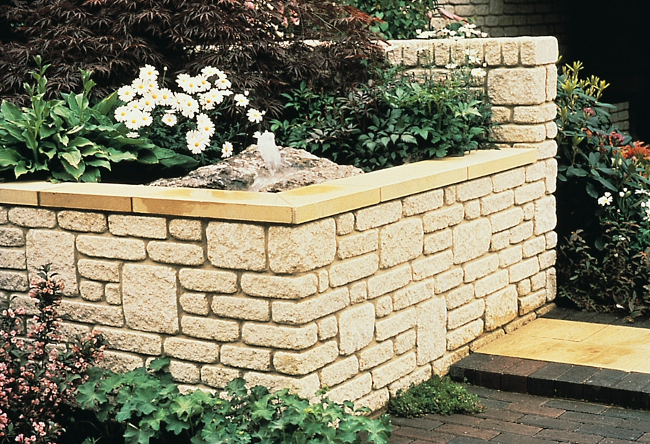
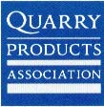
This is a unit which introduces young children to geography field work.
The children will look at the walls of buildings in their local area.
They will be introduced to some of the purposes and origins of some common building materials.
The unit mirrors the opportunities of those in the QCA unit for links to literacy, mathematics, speaking and listening, design and technology, history, IT and the world of work. It also has links to science, drama and, importantly, education for sustainable development. I.e. this unit helps children acquire the basic knowledge that will help them eventually discriminate between which of the Earth’s resources are renewable and which are finite.

