Notes for teachers

To use this Big Book select:
- View – Reading Layout;
- On the toolbar select the multiple page option..

This Big Book has been designed to be viewed on an interactive white board or large visual display unit.

You may prefer to substitute local photographs to make the book even more relevant to your children.

Please delete this text box prior to use.

Waggy.
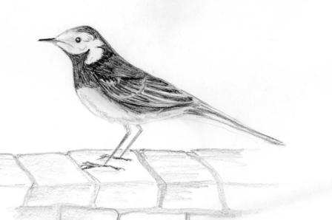

A Wonderful Wall Watcher.
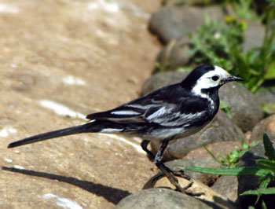
(Photo courtesy of http://www.copyright-free-pictures.org.uk)

I am called a wagtail!

Do you know why?

I look at walls very carefully.

What do you think I am looking for?
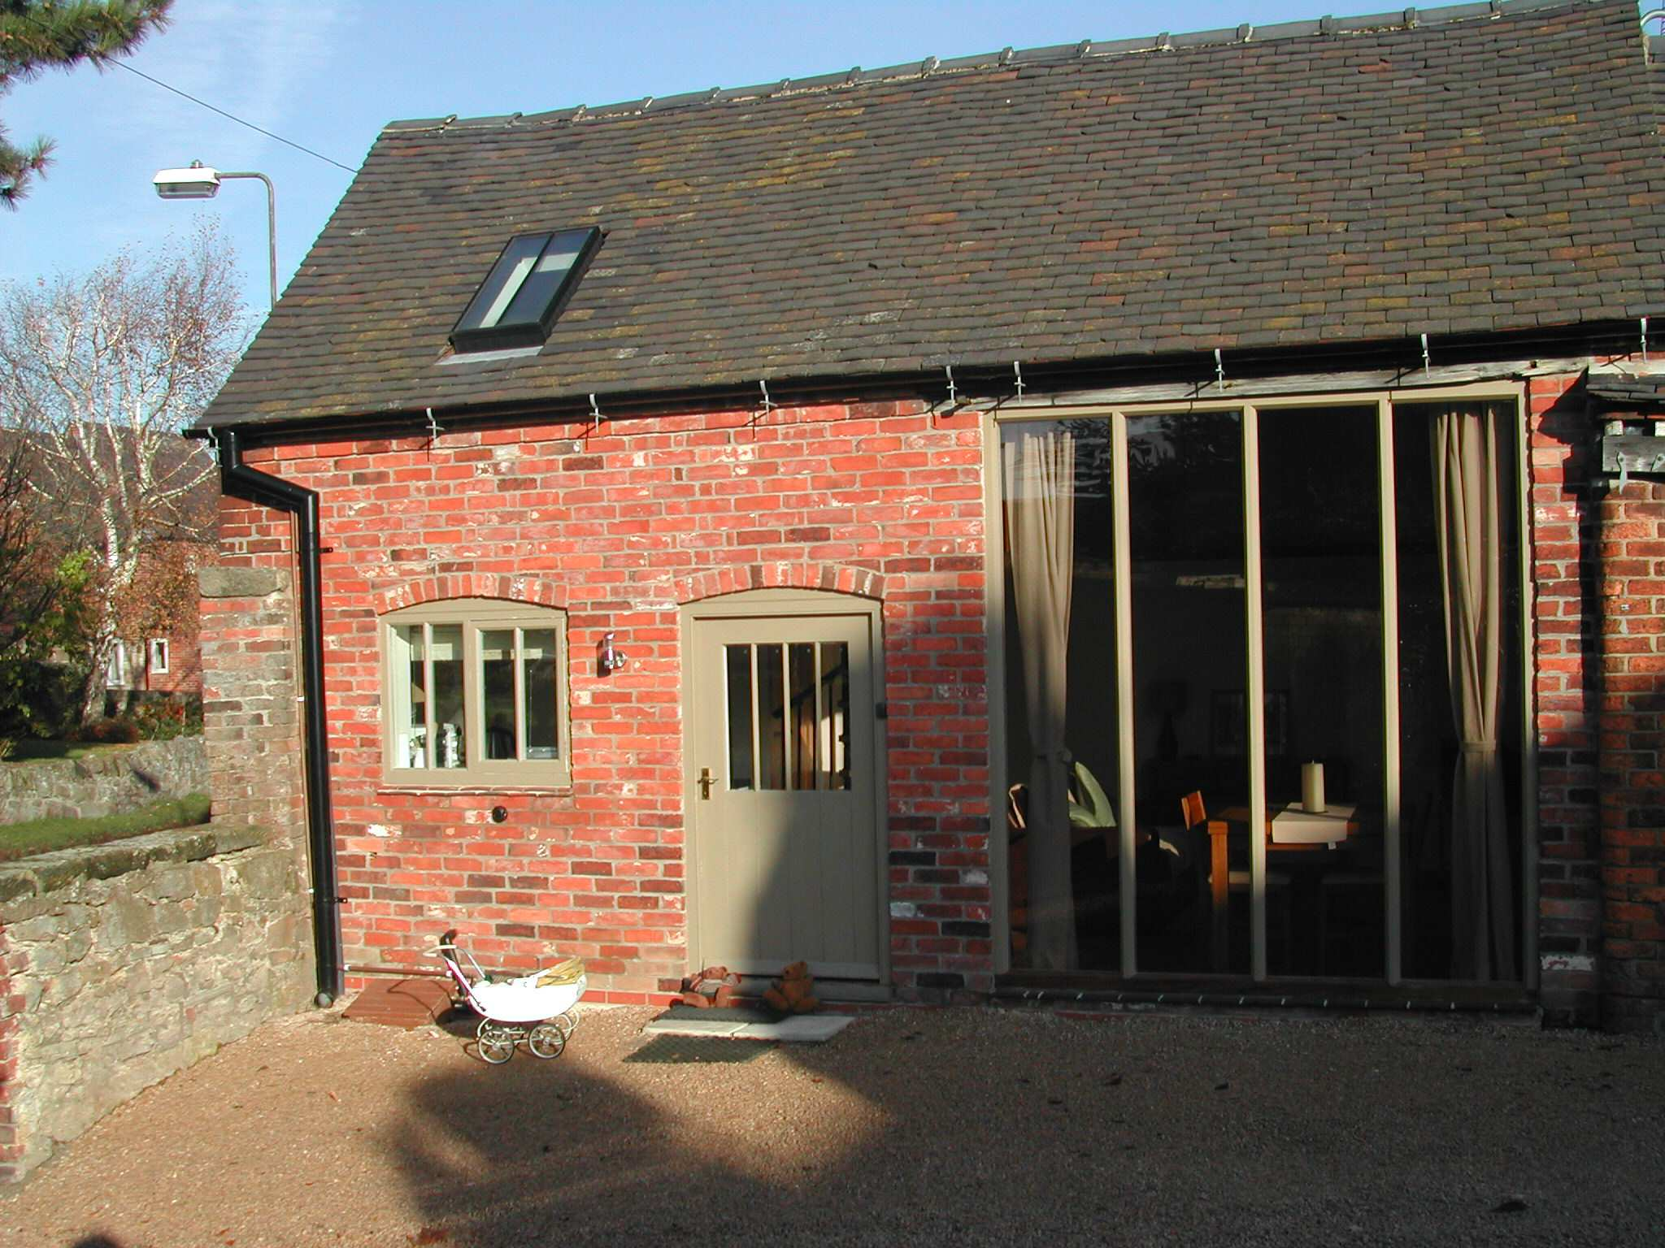

Look at these walls.

Why do you think these walls were built?

What do you think the walls are made of?
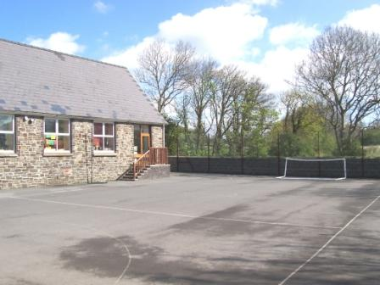

Look at these walls!
What do you think is going on here?

Why were these walls built?

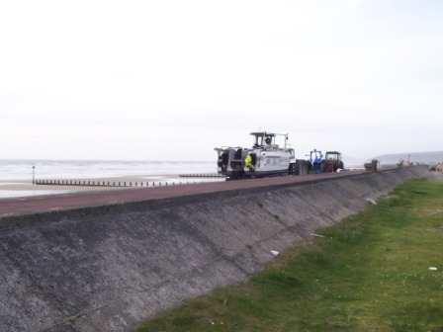

Here is another wall.

Where do you think this wall is?

Why do you think it was built?
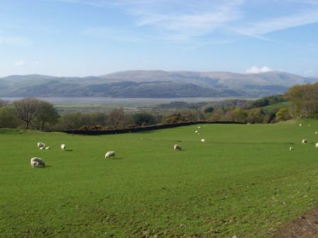

Here is another wall. Wagtails like this wall.
Where do you think you would find a wall like this?

Why do you think wagtails like this wall?

