Notes for teachers

To use this Big Book select:
- View – Reading Layout;
- On the toolbar select the multiple page option..

This Big Book has been designed to be viewed on an interactive white board or large visual display unit.

You may prefer to substitute local photographs to make the book even more relevant to your children.

Please delete this text box prior to use.
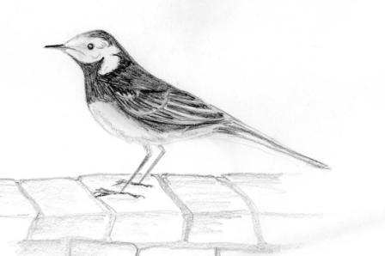
Waggy wants to know why people keep changing things.
What is happening here?

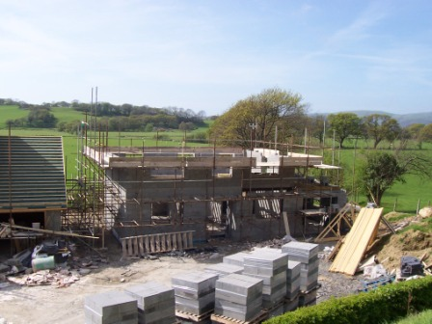
What do you think was here a long time ago?

What do you think it will look like next year?
Now look at this!

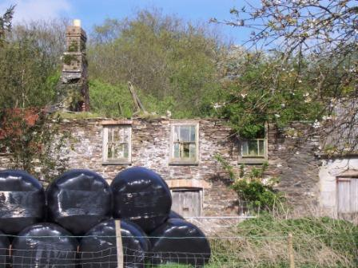
What do you think was here a long time ago?

What has happened?

Could you make some changes?
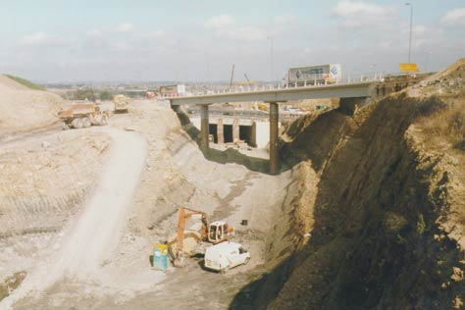

Photo by Adrian Shawcross courtesy of www.cbrd.co.uk

What do you think is happening here?
Why are they changing this place?

What do you think it will be like next year?

Now look at this!
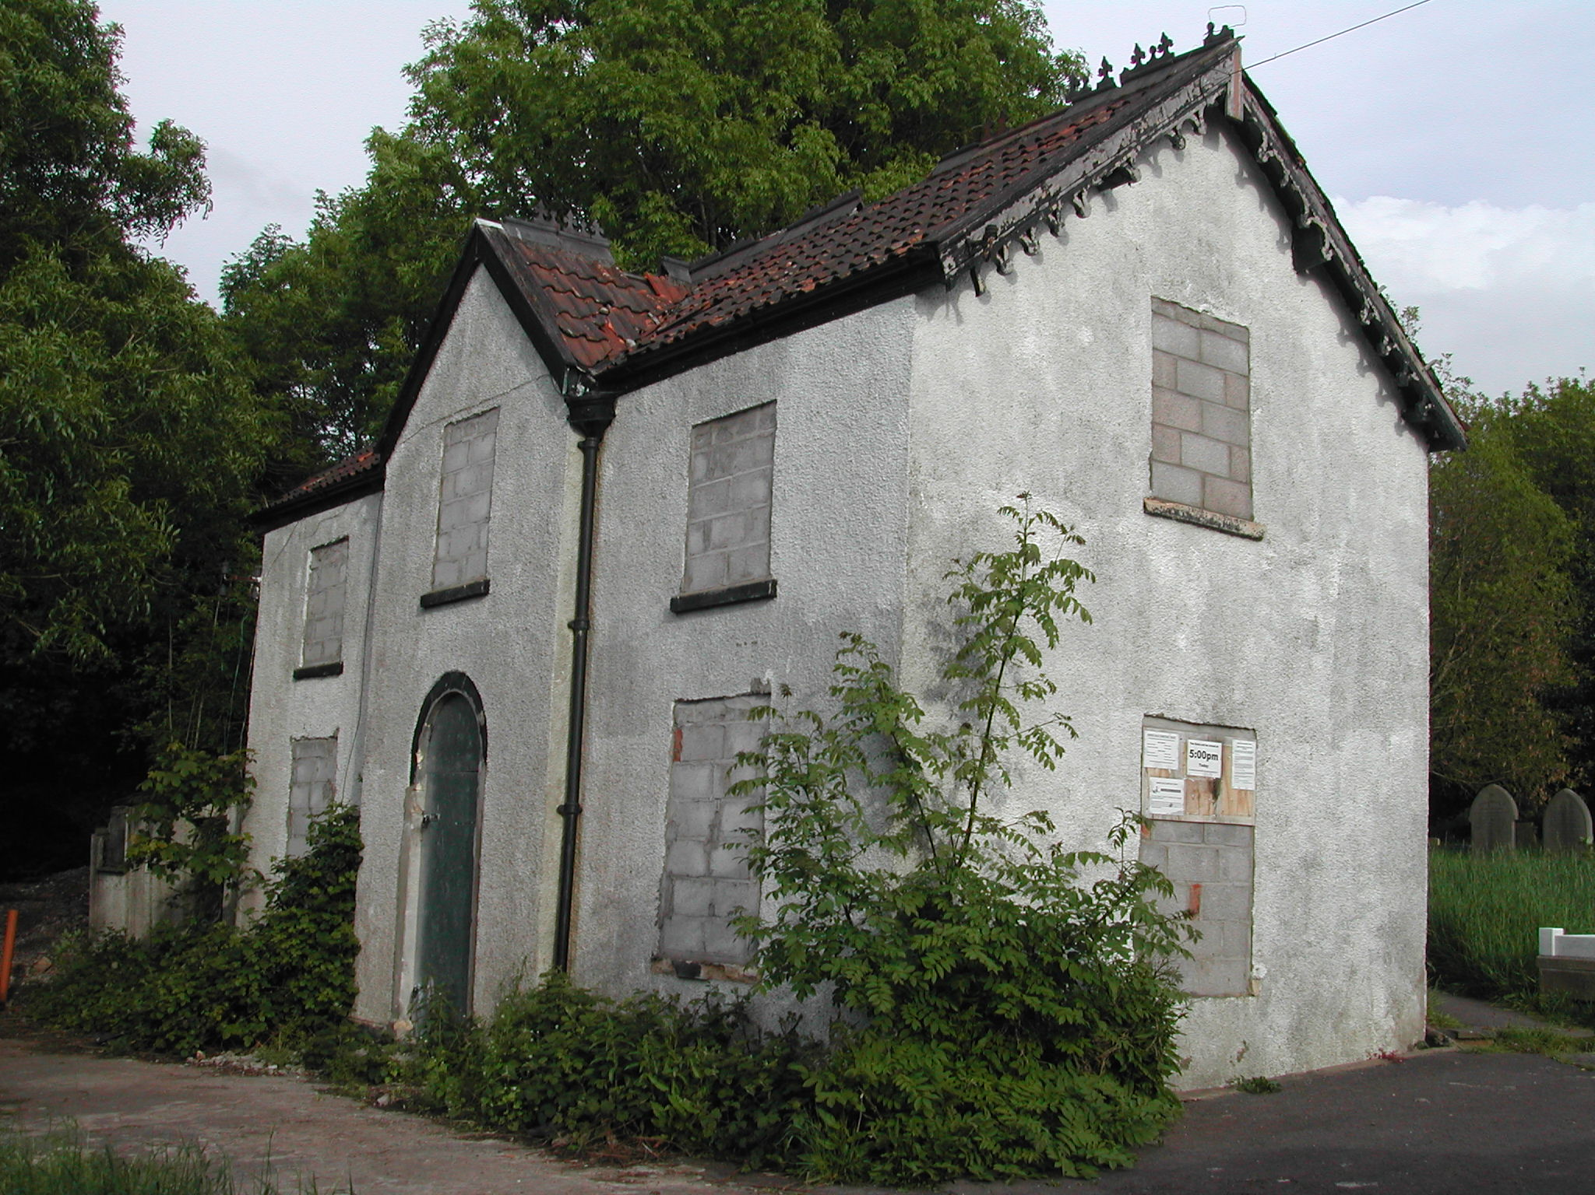
What was here a long time ago?

What has happened?

Would you make any changes here?
What do you think is happening here?
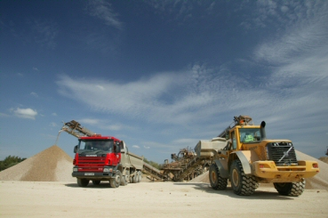
What do you think they are digging out of the ground?

What will it be like in a few years time?
I’d like it to be like this!

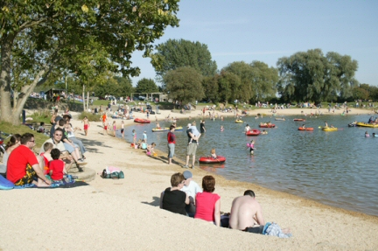
Do you know why?

