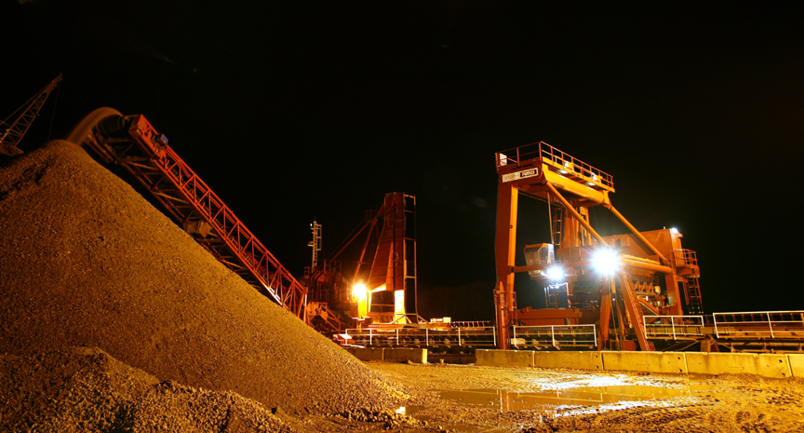

In this unit, pupils explore the nation’s increasing needs for sand and gravel from marine sources, the strict controls imposed on its extraction and the environmental costs and benefits involved.

The Government’s plans for a significant increase in house building, London’s successful bid for the 2012 Olympics and the need for coastal defence schemes will require a sustainable increase in the supply of marine aggregates. Increasing environmental pressures on land-based resources make it likely that marine resources – currently providing for around 20% of our sand and gravel needs – will be critically important.
Will increased marine aggregate dredging destroy archaeological remains, threaten our coastline and harm our already fragile marine wildlife, or are the current safeguards adequate? What are the worldwide implications of using marine aggregates and how do different countries control their production?
The unit also looks at two case studies – Hallsands in South Devon, a scheme from 100 years ago when scientific knowledge was minmal and social responsibility was a small consideration, and the North Norfolk coast, a modern scheme designed to avert serious environmental changes caused by natural coastal erosion.

The unit offers opportunities for first-hand research (site visits and questionnaire), the use of secondary sources (local press, radio and TV reports, internet), role-plating exercise (a public enquiry) and the production of a report which can be submitted to the Local Authority, the Environment Agency and the local marine aggregate producer.

