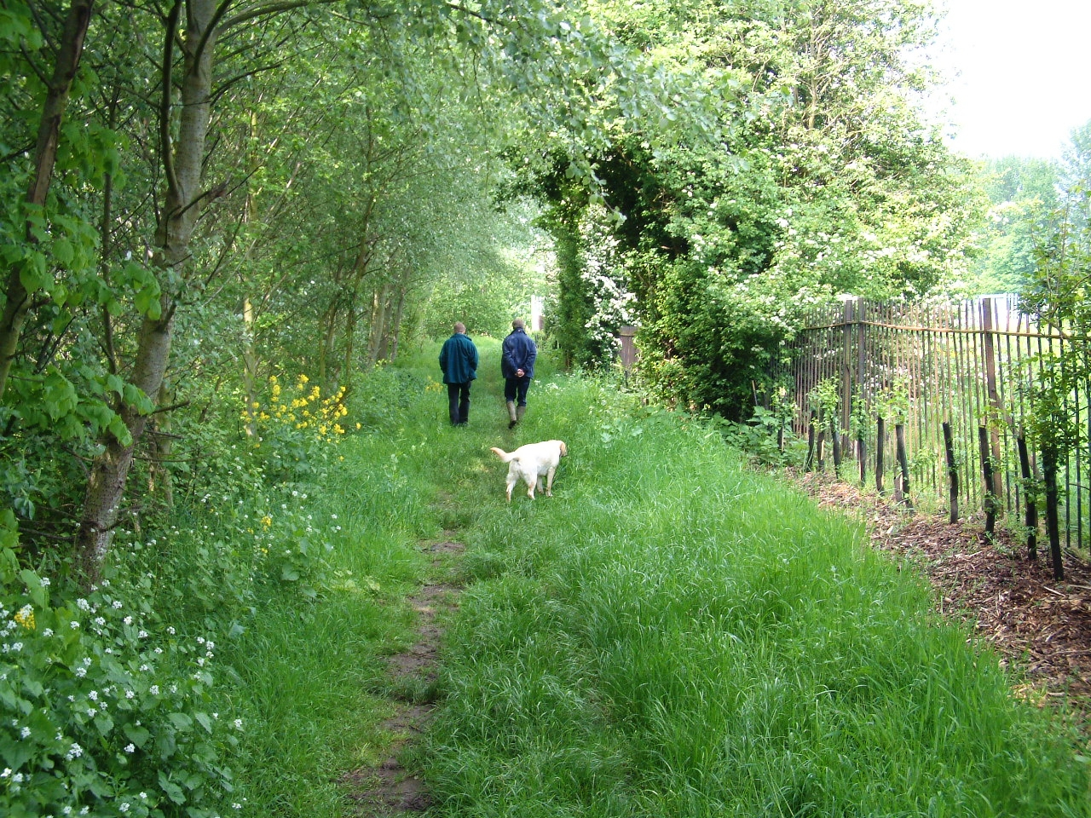

Through this module pupils will be encouraged to
- Research and use existing scientific knowledge
- Decide on the appropriate use of first-hand observations or secondary sources
- Set up a pilot study and consider key factors; make testable hypotheses
- Design suitable recording sheets and analysis spreadsheets with accurate calculations at an appropriate level of precision
- Use a range of equipment appropriately and safely, recording to appropriate levels of precision
- Decide on how to present observations
- Evaluate results in the light of original hypotheses and scientific knowledge
- Consider anomalous data and the quantity and reliability of their own data
- Suggest improvements to methods and design further investigations
- comment on the suitability and sustainability of the management methods employed in the woodland in the restored quarry
- The subject of woodland in restored quarries will be explored in the context of the habitats provided in suitable locations. However the work will be equally relevant to woodland in other situations.

